CITSMS System Usage Documentation

Contents
What is the CITSMS System? 2
Security and Acceptable Use 2
Requirements for using CITSMS 2
Standard staff access 2
Elevated staff access 2
Two Factor Authentication 3
Google Authenticator 3
Activating Two Factor Authentication 3
Problems with Two Factor Authentication 4
Using the CITSMS System 5
Logging In 5
Overview 6
Adding your Mobile Number 7
Sending a Bulk SMS 8
Sending an SMS to a CRN 9
Show Sent SMS 10
System Documentation 10
Logging Out 10

What is the CITSMS System?
The CITSMS system allows CIT staff to send text messages (SMS) through an online web portal, which includes the ability to send to CRN student lists, bulk number messages, as well as whole campus/CIT. With the ability to now access CITSMS externally via the internet, staff can now access this from anywhere the internet is available from most devices as well as providing a means of communication in emergency/disaster scenarios.

Security and Acceptable Use
The CITSMS system is provided for official CIT business use only. When a user logs into the system their account and PC details as well as the time and date are recorded for auditing and security purposes. It is therefore important for each user to ensure the security of any machine they are logged into the CITSMS system on as any misuse of the system will be attributed to their login
This system is also covered by the Acceptable Use of ICT Resources Policy

Requirements for using CITSMS

Standard staff access
In order to access the CITSMS system, staff must first be setup with a CIT network login which allows access to the CIT Admin network. It is highly encouraged staff setup two factor authentication for the additional security; however this is not required for standard user access.

Elevated staff access
In addition to requiring a CIT network login, staff members who have elevated access within the CITSMS are required to setup two factor authentications.

Two Factor Authentication
Two factor authentication has been added to the CITSMS system to provided added login security, which can be easily setup on any Android or Apple mobile device.

Google Authenticator
In order to use two factor authentication, you will need Google Authenticator to manage the registration. This can install from the Google Authenticator application from either the Apple App Store or the Google Play Store onto your mobile. It is highly recommended that you only download this from the Apple App Store or Google Play Store, as third party sites may not be secure. You will need a Google account or Apple ID to do this.
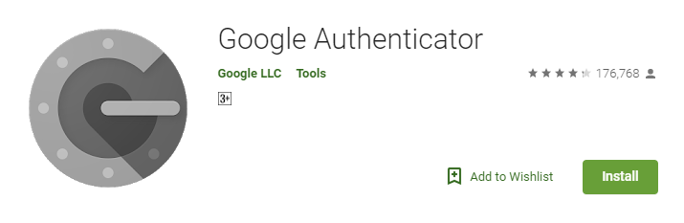

Activating Two Factor Authentication
Once Google Authenticator has installed, you can activate two factor authentication on your CITSMS login.
For standard users, select ‘Manage Two Factor’ after logging into the CITSMS system.
For users with elevated privileges, you will need to setup two factor authentication before you can log on, and will be presented with a link to follow for this effort.
On either of these pages you will be able to generate a QR code which is to be scanned by Google Authenticator. First the ‘Add an Account’ screen has not already appeared on Google Authenticator, click the ‘+’ icon in the bottom right and select ‘Scan a barcode’.
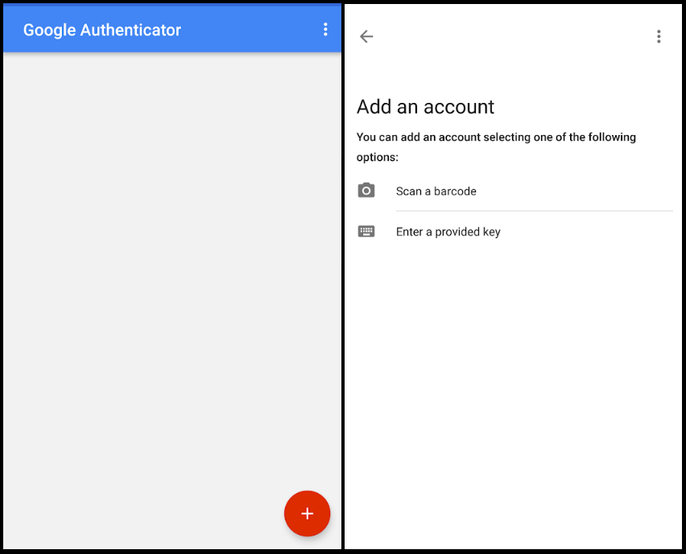
This will bring up your camera on your phone, at which point you will need to use it to scan the QR code. Once the QR code has been scanned, it will display a validation code which will need to be entered at the bottom CITSMS website below the QR code.
Once this validates, you will have successfully setup two factor authentication and it should appear in your Google Authenticator.

Problems with Two Factor Authentication
If you experience issues with setting up Two Factor Authentication or during login after setting it up, please see the ‘Problems with Two Factor Login’ tab on the CITSMS system. This page is available even when you are not logged on.

Using the CITSMS System

Logging In
There are three ways to log in:
- Via the link on the bottom of the SIS home page under Other Systems
- Via the CIT website on the staff page
- Putting the https://citsms.cit.edu.au/Default.aspx in your web browser.
You will be greeted by the login screen below.

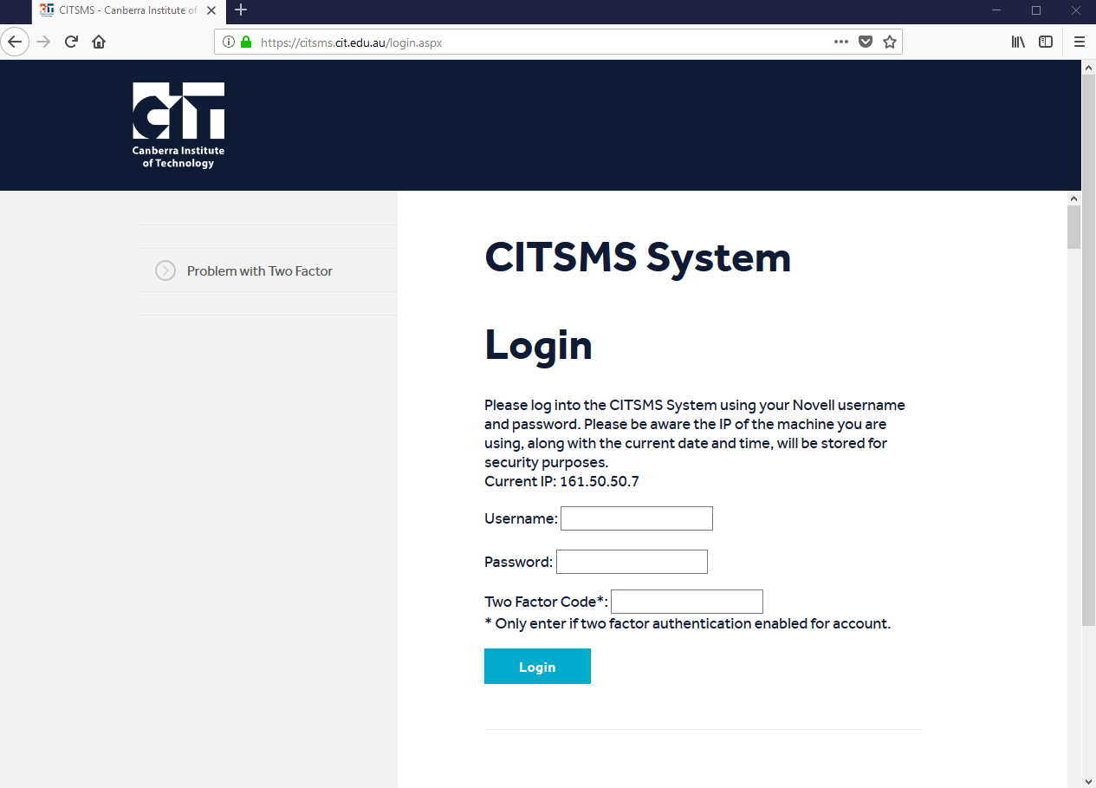

At this screen you enter your CIT username and password into the specified textboxes and if you have been assigned an access role in the system you will be granted access.
If you enter an incorrect username/password combination you will be warned of the fact and your initial login count of 3 will be decreased by 1. If your username has the incorrect password entered 3 times, it will be blocked from further attempts to log into the system and you will have to send an email to ICTSharedServices@act.gov.au to request an unblock.
Once you are logged on you will see the following welcome message and be directed to the appropriate links in the left hand menu for sending an SMS to either bulk numbers or specific CRN’s.
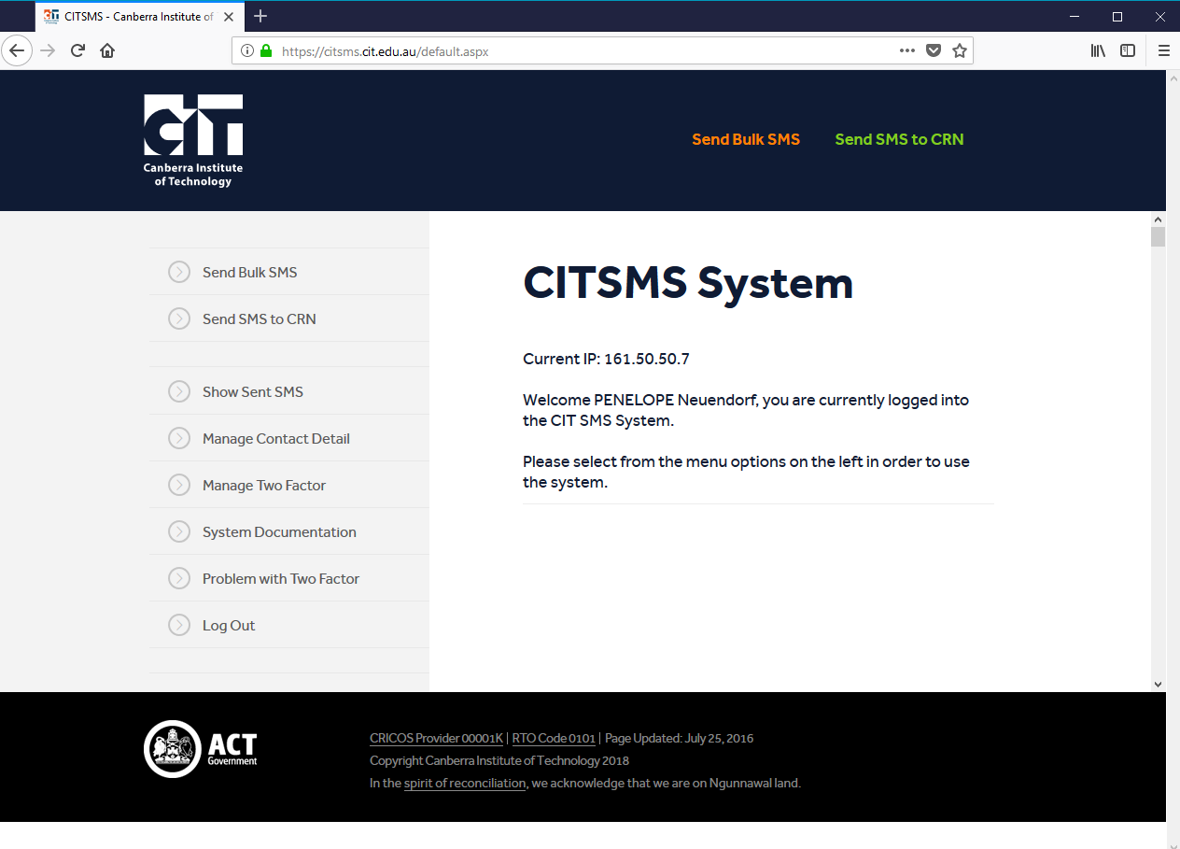

Overview
General users of the system will see 3 links in the left hand navigation panel with the first two allowing them to send an SMS message to a CRN (or multiple CRN’s if needed) and the second link allows users to send an SMS message to a list of numbers supplied by the user, either by entering them manually or using a file containing the numbers.
Administration level users will also see ‘Assign a User’ and ‘Unblock User’ links as well, the usage of which will be explained below.
The final link available to users is the ‘Log Out’ link which logs you fully out of the system and should be used before closing the browser window instead of just closing the browser, which will not log you out. If the ‘Log Out’ option is not used first, anyone that gains access to your pc and opens a new browser window will still be logged into the CITSMS system if they navigate to it.

Adding your Mobile Number
The CIT SMS system has been enhanced to include the option for staff to be contacted in case of emergencies e.g. burst water main or power outage.
To add your mobile number, select Manage Contact Details and insert your preferred mobile number. You can change your number as needed.

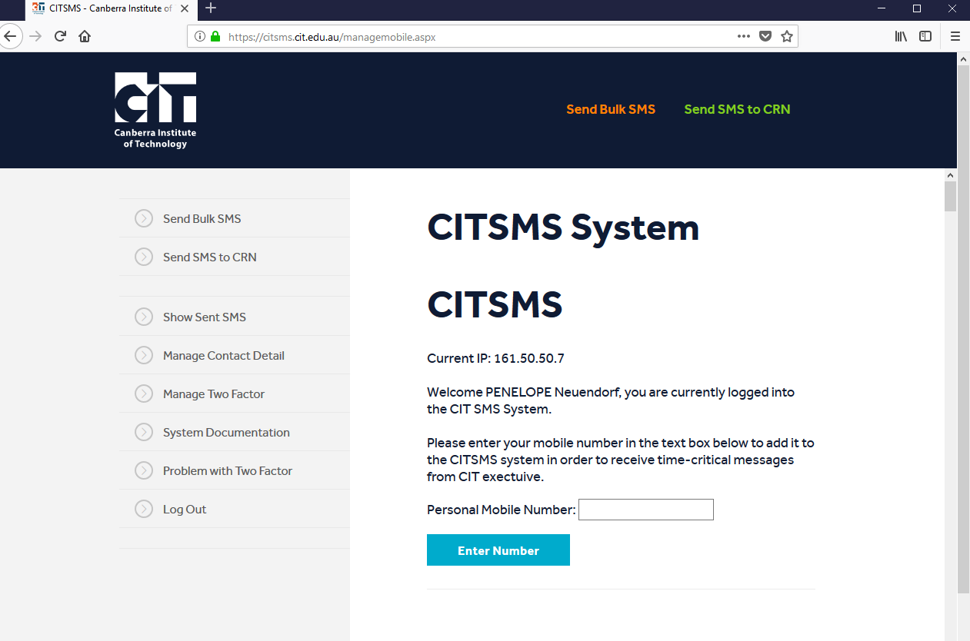

Sending a Bulk SMS
To send an bulk text message to numbers that aren’t yet part of a CRN (eg people wanting to be notified about information session days) using the CITSMS system, once logged in click the ‘Send Bulk SMS’ link in the left hand menu and you will be taken to the following screen.

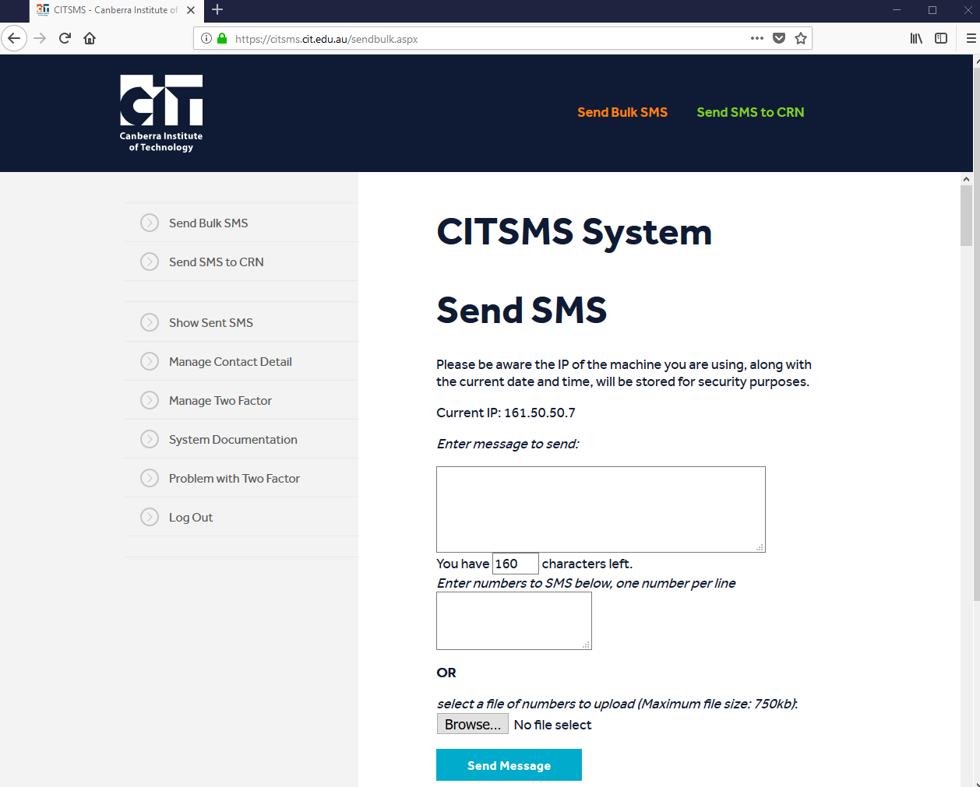
You will then need to fill in the message you wish to send (e.g. “Your business systems information session will be on 14/09/18 at 2pm”), up to a maximum of 160 characters in length and can then choose to enter the list of mobile numbers to send the message to in the provided text area or upload a text file containing the numbers using the file upload box. If a file is uploaded and numbers entered into the text area, the uploaded file will be the source of numbers used and any in the text area will be ignored.
In either the text file (created using Notepad) or numbers input directly into the text area all numbers must start with 04, they must be 10 digits long, there must be no extraneous characters or spaces in them and there must be one number per line (i.e. press the enter key after each 10 digit number has been typed in).
After this, click the ‘Send Message’ button once, after which a message will appear below the text area informing you of the success or failure of the process. It is recommended to include your own number as an additional step to ensure the text messages were correctly sent.

Sending an SMS to a CRN
To send an SMS to students within a CRN using the CITSMS system, once logged in click the ‘Send SMS to CRN’ link in the left hand menu and you will be taken to the following screen.

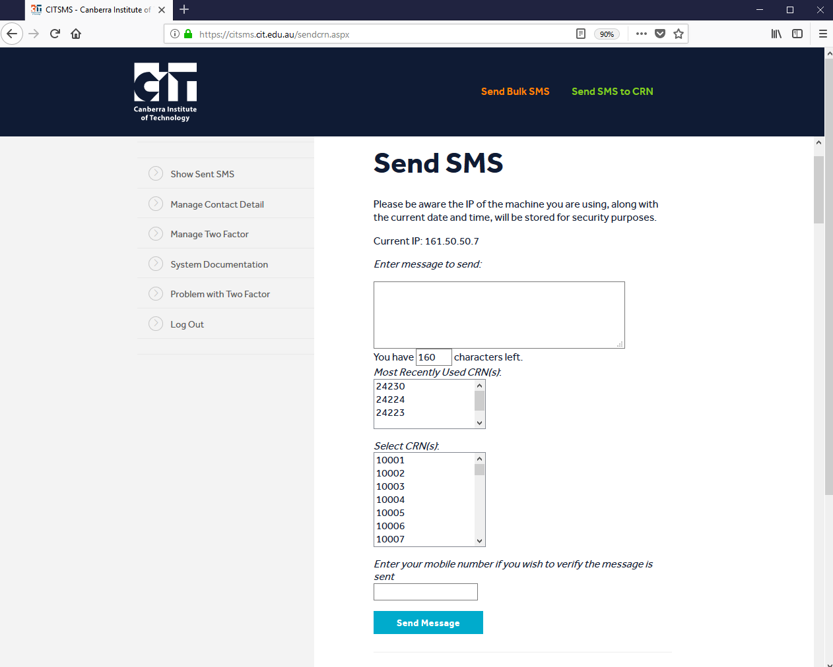

You will then need to fill in the message they wish to send (e.g. “Your business systems information session will be on 14/11/07 at 2pm”) up to a maximum of 160 characters in length and the year, then select the semester the CRN is run in from the dropdown box before selecting the CRN(s) you wish to SMS. Finally click the ‘Send Message’ button to send the text message.
After this process is completed the system will display a completed message, along with a list of any students that have bad data for their mobile number and thus can’t be messaged. These students will receive the sent message at their student mail address.
N.B. Multiple CRNs can be selected by holding down the CTRL key as the user clicks

Show Sent SMS
You have the option to see the SMS’s that you have sent by clicking on Show Sent SMS and putting in the required dates.

System Documentation
Updates to documentation are found under the System Documentation.

Logging Out
To log out of the CITSMS system, you merely have to click the ‘Log Out’ button in the left-hand menu and you will be logged out of the system.
If this is not used you will stay logged on for 12 hours after you first logged in and anyone that gains access to your computer will have access to the CITSMS system.
Any messages sent through the CITSMS system will be attributed to the logged in user and thus it is suggested that you always log out of the CITSMS system using the ‘Log Out’ link when they are not at your computer.

